Using Decimals
There are a lot of areas where decimals are used. Some of them are:

Weight
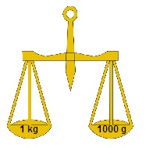
1kg = 1000 grams
gram = 1/1000 kgs
1 gram = 0.001 kgs

Money
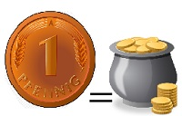
1 Rs. = 100 paise
1 paise = 1/100 paise
1 paise = Rs. 0.01

Length
1metre = 100 cms
1 cm = 1/100 m
1cm = 0.01 m

Problems: Express 75 paise as rupees using decimals.
Solution:
Rs1 = 100 paise
1 paise = 1/100 = Rs 0.01
75 paise = Rs. 75*0.01
= Rs. 0.75
Problems: Express 5 kg 8 g as kg using decimals.
Solution:
5kg is already in the unit of kg. So we will convert 8 g.
1kg = 1000 g
1 g = 0.001 kg
8 g = 8*0.001 kg
8g = 0.008 kg
Now 5kg 8g = 5kg + 8g
To make the addition possible, both the values must be in the same unit.
5kg 8g = 5kg + 0.008 kg
5kg 8g = 5.008 kg.

